Tailscale Interface for Remote access:

echo "nameserver 1.1.1.1
nameserver 8.8.8.8" | sudo tee /etc/resolv.conf

ping -c 2 region1.v2.argotunnel.com

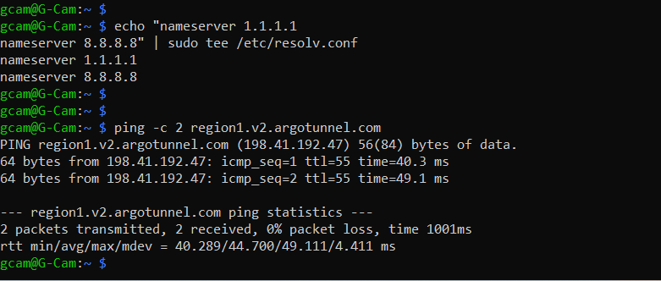

Step 1:
curl -fsSL https://tailscale.com/install.sh | sh

Step 2:
sudo apt-get update
sudo apt-get install tailscale
sudo systemctl enable --now tailscaled
sudo tailscale up

It will give a login URL.
Open it in browser and sign in.

Step 3:
sudo tailscale up --ssh

Step 4:
tailscale ip -4

Host Mail ID – krishna.realtechs1@gmail.com
Admin Mail ID – mfgrts@gmail.com (*Use This to Login)

